Temporary Engineering Change Request Information
TECN Number: |  | ECN Title: | Communication System Temperature Monitoring
Date: | 7/10/2017 | ECN Originator: | Hyundai Rotem/Woojin/DTS
ECN Schedule: | ASAP | Component Effected: | Communication System/CRA

Temporary Engineering Change Request Description
Hyundai Rotem and the communication system supplier, Woojin, are investigating the random and constant
Automatic announcement failures that have been experienced over the past year of revenue service. There
Is a suspicion that the CRA unit, which houses the communication system control boards, is getting too hot
And is causing the board controlling the automatic announcements to temporarily fail/fault. Woojin is
Proposing to install fans and temperature recorder equipment on the CRA in 10 cars: 4009/4025/4043/
4044/4045/4049/4057/4061/4062/4066 to determine the root cause and permanent solution. The temporary equipment will be installed for 3 days.
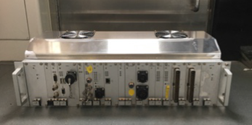
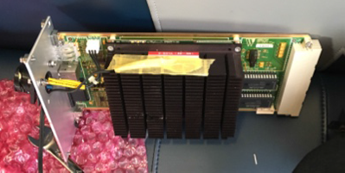

Temporary Engineering Change Required Documents
 | Required | Supplied
Work instructions:
Design drawings:
Technical description:
Maintenance manual:
Parts list / manual:
Test plan:
Test procedures:
Interface documents:
Communication plan:

DTO Configuration Management Board Approval
Title | Date | Approved (Y/N) | Printed Name | Signature
General Manager |  |  | Anne Herzenberg
Chief Engineer |  |  | Mario Santiago
Chief Transportation Officer |  |  | Frank Hauser
Chief Mechanical Officer |  |  | Carl Atencio
Chief Safety Officer |  |  | Barry McGauley

Disposition (Circle the one that applies)
Approved As Submitted | Approved With Modifications | Rejected See Attached Explanation | Resubmit Changes Required

Distribution Instructions:
Original – DTO Document Control Permanent Record
1 copy DTO Chief Engineer 1 copy DTO Chief Mechanical Officer
1 copy DTO Chief Transportation Officer 1 copy – Originator

